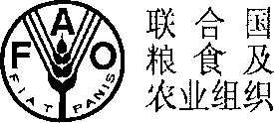

FOOD AND AGRICULTURE ORGANIZATION OF THE

UNITED NATIONS

3,.,,,, a LA \ n a

? oSU 3 J

ORGANISATION DES NATIONS UNIES POUR LAUMENTATION ET L’AGRICULTURE

ORGANIZACION DE LAS NACIONES UNIDAS PARA

LA AGRICULTURA Y LA ALIMENTACION

OFFICE OF THE SUB-REGIONAL COORDINATOR FOR THE PACIFIC

**Mailing Address:**

**Telephone: Facsimile:**

(685) 20710; 22127 (685) 31313

**Email:**

[SAP-SRC@fao.org](mailto:SAP-SRC@fao.org)

Private Mail Bag

Apia

SAMOA

Our ref.:

27 August 2019

Dear Secretary,

**Subject; Global Agriculture Food Security Program**

On behalf of FAO, I am pleased to confirm that FAO stands ready to support the ‘Small Islands Food and Water Project’ as supervising entity for technical assistance.

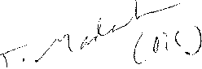

Yours Sincerely,

Eriko Hibi

FAO Representative for Federated States of Micronesia

Honourable Marion Henry

Secretary

Department of Resources and Development

Federated States of Micronesia

Cc: Ms Marlyter Silbanuz, Program Manager, Department of Resources and Development

Mi* Lorin S Robert, Secretary, Department of Foreign Affairs

Ms Silina Lawrence, Secretary, Department of Finance and Administration

Ms Wadzanai Gar we, Economist Investment Centre, FAO

Ms Fiasili Lam, Policy Officer, FAO